OBJECT ORIENTED CONCEPTS
In case of an Object Oriented System, the overall architecture of the system is perceived as a collection of objects that are assigned specific responsibilities. These objects exhibit their behavior based on the type of responsibility assigned to them. Thus the main goal of the system is achieved thru the collaboration of objects that exist in the system.
The steps in designing an Object Oriented System comprises of mainly
- Identification of objects that exist in a domain
- Assigning responsibilities to these objects so that each object can exhibit the desired
behavior
- Seek collaboration between these objects for fulfilling the goal of the system (computation as a simulation)
Responsibility Driven Design
Just like in our daily lives we get to see different entities fulfilling their goals independently, in case of an object oriented system, objects exhibit behavior based on the kind of responsibility that has been assigned to it. We expect a lamp to glow whenever we pass it a message to glow by switching the lamp on and we do not expect a lamp to rotate or make sound.
Decomposition
It is the process of partioning the problem domain into smaller parts so that the overall complexity of the problem can be comprehended and tackled easily (divide and conquer approach)
- Algorithmic/Functional decomposition
Dividing the problem domain into smaller parts by focusing on the functionalities that the system provides. For example functionalities of a Library Management System may include issue_book, return_book, search_book
- Object Oriented Decomposition
Dividing the problem domain into smaller parts by focusing on the objects with specific responsibilities that form the system. For example, objects in a Library Management System may include IssueManager, Book, Librarian
In an object oriented system, the overall goal of the system is decomposed into sub goals and then responsibilities are assigned to specific objects.
So the overall functionality of the system is achieved thru the collaboration of these objects.
Abstraction
Abstractions are created by hiding the details and representing only the necessary features
Forming abstractions help in communicating ideas with others and in representing complexity in a much simplified form.
Abstractions can be formed of objects, ideas or functionalities.
- moving towards the door
- grabbing its handle
- pulling it towards you
So if you want to ask someone to open the door you do not need to relate to him the details regarding how it is done every time
A person who is a human being , who has a name and id, who works in a library, who can issue, return and stock book is represented by an abstraction called Librarian
It means to filter out an objects property and operations until just the one needed are left
Object-oriented analysis
It is method of analysis that examines requirements from the perspective of the classes and objects found in the vocabulary of the problem domain
A thorough investigation of the problem domain is done during this phase by asking the WHAT questions (rather than how a solution is achieved)
During OO analysis, there is an emphasis on finding and describing the objects (or concepts) in the problem domain.
For example, concepts in a Library Information System include Book, and Catalog.
Object-oriented design
It is method of design encompassing the process of the object oriented decomposition and notation for depicting both logical and physical as well as static and dynamic models of the system under design
There are two important parts of this definition
It leads to object oriented decomposition
Uses different notations to express different models of the logical (class and object) structure and physical (module and cross architecture) design of a system in the addition to the static and dynamic aspects of a system
Emphasizes a conceptual solution that fulfils the requirements.
There is a need to define software objects and how they collaborate to fulfill the requirements.
For example, in the Library Information System, a Book software object may have a title attribute and a display() method. The issueManager may be asked to issue a book, in response this object may ask the BookRecord object to update the status of the book.
Designs are implemented in a programming language.
OOA | OOD
Elaborate a problem | Provide conceptual solution
WHAT type of questions asked | HOW type of questions asked
During Analysis phase questions asked include  Q. What is required in the Library Information  System?  A. Authentication!! | Later during Design phase questions asked include  Q. How is Authentication in the Library  Information System achieved?  A. Thru Smart Card!! Or Fingerprint!!

Object Oriented Programming
It is a method of implementation in which programs are organized as co operative collection of objects each of which represents an instance of some class and whose classes are all members of a hierarchy of classes united via inheritance relationship.
Three important aspects of definition
- Uses objects not algorithms as fundamental building blocks
- Each object is an instance of some class
- Classes are related to one another via inheritance
Characteristics of OOD
Objects are abstractions of real-world or system entities and manage themselves
Objects are independent and encapsulate state and representation information.
System functionality is expressed in terms of object services
Shared data areas are eliminated. Objects communicate by message passing
Objects may be distributed and may execute sequentially or in parallel
Advantages of OOD
Easier maintenance. Objects may be understood as stand-alone entities
Objects are appropriate reusable components
For some systems, there may be an obvious mapping from real world entities to system objects
Object-oriented development
Object-oriented analysis, design and programming are related but distinct
OOA is concerned with developing an object model of the application domain
OOD is concerned with developing object-oriented system model to implement requirements
OOP is concerned with realizing an OOD using an OO programming language such as C++
Object-oriented design methods
Some methods which were originally based on functions (such as the Yourdon method) have been adapted to object-oriented design.
Other methods such as the Booch method have been developed specifically for OOD
OOD is an object-oriented design method developed to support Ada programming.
OO Design method commonality
The identification of objects, their attributes and services
The organization of objects into an aggregation hierarchy
The construction of dynamic object-use descriptions which show how services are used
The specification of object interfaces
Objects
An object is an entity which has a state and a defined set of operations which operate on that state.
The state is represented as a set of object attributes.
The operations associated with the object provide services to other objects (clients) which request these services when some computation is required.
Objects are created according to some object class definition. An object class definition serves as a template for objects. It includes declarations of all the attributes and services which should be associated with an object of that class.
Objects are entities in a software system, that represent instances of real-world and system entities
Object classes are templates for objects. They may be used to create objects
Object classes may inherit attributes and services from other object classes
Assigning Responsibilities
A critical, fundamental ability in OOA/D is to skillfully assign responsibilities to software components
It strongly influences the robustness, maintainability, and reusability of software components.
In an object oriented system every object is capable of accomplishing a specific goal and it does so by fulfilling the responsibilities assigned to it.
e.g. a dice object can come up with a random face value by fulfilling the responsibility it has been assigned that is to roll()
e.g. a book object can reveal its name by fulfilling the responsibility it has been assigned that is to getBookInfo()
Analysis and Design
Analysis emphasizes an investigation of the problem and requirements, rather than a solution. For example, if a new computerized library information system is desired, how will it be used?
"Analysis" is a broad term, best qualified, as in requirements analysis (an investigation of the requirements) or object analysis (an investigation of the domain objects).
Design emphasizes a conceptual solution that fulfills the requirements, rather than its implementation. For example, a description of a database schema and software objects. Ultimately, designs can be implemented.
Analysis and design have been summarized in the phase do the right thing (analysis), and do the thing right (design).
Object-Oriented Analysis and Design
During object-oriented analysis, there is an emphasis on finding and describing the objects—or concepts—in the problem domain. For example, in the case of the library information system, some of the concepts include Book, Library, and Patron.
During object-oriented design, there is an emphasis on defining software objects and how they collaborate to fulfill the requirements. For example, in the library system, a Book software object may have a title attribute and a getChapter method
Finally, during implementation or object-oriented programming, design objects are implemented, such as a Book class in Java.
Object-orientation emphasizes representation of objects.
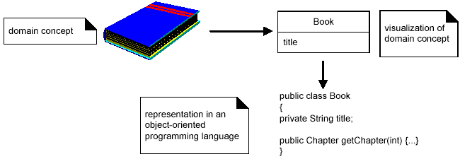
An Example
A birds-eye view of steps and diagrams involved in a "dice game" in which a player rolls two die. If the total is seven, they win; otherwise, they lose.
i. Define Use Cases
Requirements analysis may include a description of related domain processes; these can be written as use cases.
Use cases are not an object-oriented artifact—they are simply written stories.
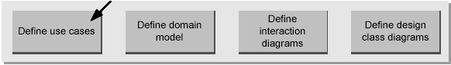
However, they are a popular tool in requirements analysis and are an important part of the Unified Process. For example, here is a brief version of the Play aDice Game use case:
Play a Dice Game: A player picks up and rolls the dice. If the dice face value total seven, they win; otherwise, they lose.
ii. Define a Domain Model
Object-oriented analysis is concerned with creating a description of the domain from the perspective of classification by objects. A decomposition of the domain involves an identification of the concepts, attributes, and associations that are considered noteworthy. The result can be expressed in a domain model, which is illustrated in a set of diagrams that show domain concepts or objects.
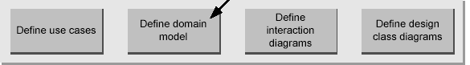
Note that a domain model is not a description of software objects; it is a visualization of concepts in the real-world domain.
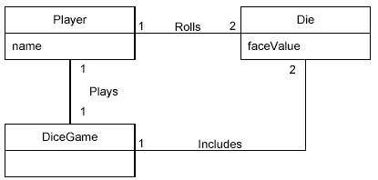
iii. Define Interaction Diagrams
Object-oriented design is concerned with defining software objects and their collaborations.
A common notation to illustrate these collaborations is the interaction diagram. It shows the flow of messages between software objects, and thus the invocation of methods.
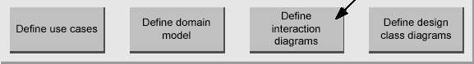
For example, assume that a software implementation of the dice game is desired. The interaction diagram in figure illustrates the essential step of playing, by sending messages to instances of the DiceGame and Die classes.
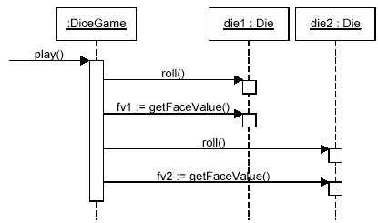
Although in the real world a player rolls the dice, in the software design the DiceGame object "rolls" the dice (that is, sends messages to Die objects). Software object designs and programs do take some inspiration from real-world domains, but they are not direct models or simulations of the real world.
iv. Define Design Class Diagrams
In addition to a dynamic view of collaborating objects shown in interaction diagrams, it is useful to create a static view of the class definitions with a design class diagram. This illustrates the attributes and methods of the classes.
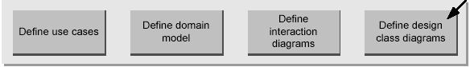
For example, in the dice game, an inspection of the interaction diagram leads to the partial design class diagram . Since a play message is sent to a DiceGame object, the DiceGame class requires a play method, while class Die requires a roll and getFaceValue method.
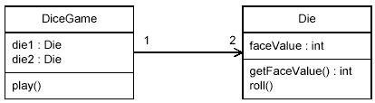
In contrast to the domain model, this diagram does not illustrate real-world concepts; rather, it shows software classes.
Requirements Process
Use Cases: Describing Processes
Writing use cases, stories of using a system, is an excellent technique to understand and describe requirements. Informally, they are stories of using a system to meet goals.
The essence is discovering and recording functional requirements by writing stories of using a system to help fulfill various stakeholder goals
“Use cases are narrative description of domain processes”
Use cases are dependent on having at least partial understanding of the system, ideally expressed in a requirements specification document.
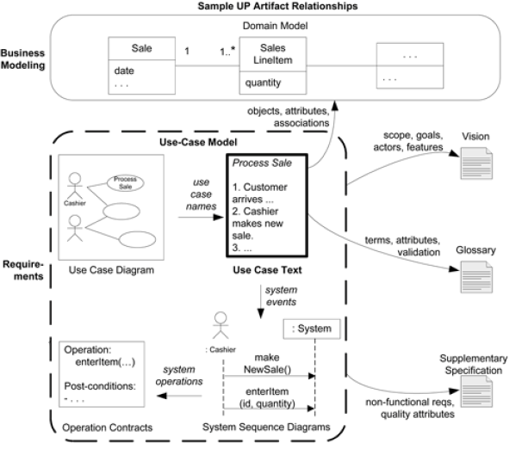
Definition: - It is a narrative document that describes the sequence of events of an actor (an external agent) using a system to complete a process.
Buy_Items

THREE USE CASE FORMATS
- Brief (High Level)
- Casual
- Fully Dressed
1. Brief—terse one-paragraph summary, usually of the main success scenario.
It describes a process very briefly, usually in two or three sentences.
It is useful to create this type of use case during the initial requirements and project scoping in order quickly understand the degree of complexity and functionally in a system.
They are very terse and vague on design decisions.
Process Sale: A customer arrives at a checkout with items to purchase. The cashier uses the POS system to record each purchased item. The system presents a running total and line-item details. The customer enters payment information, which the system validates and records. The system updates inventory. The customer receives a receipt from the system and then leaves with the items
It is useful to start with high level use cases to quickly obtain some understanding of overall major processes.
2. Casual—informal paragraph format. Multiple paragraphs that cover various scenarios.
Handle Returns
Main Success Scenario: A customer arrives at a checkout with items to return. The cashier uses the POS system to record each returned item ...
Alternate Scenarios:
If the credit authorization is reject, inform the customer and ask for an alternate payment method.
If the item identifier is not found in the system, notify the Cashier and suggest manual entry of the identifier code (perhaps it is corrupted).
If the system detects failure to communicate with the external tax calculator system, ...
3. Fully dressed—the most elaborate. All steps and variations are written in detail, and there are supporting sections, such as preconditions and success guarantees.
These detailed use cases are written after many uses cases have been identified and written in a brief format
Template:
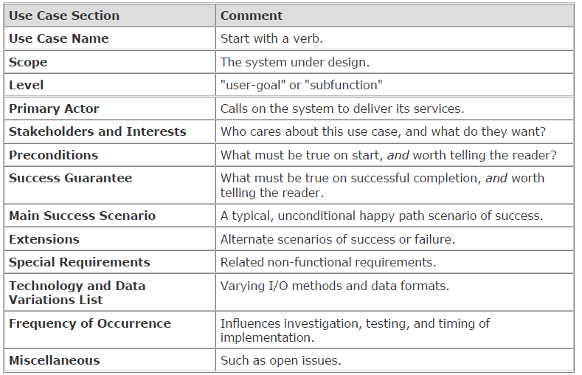
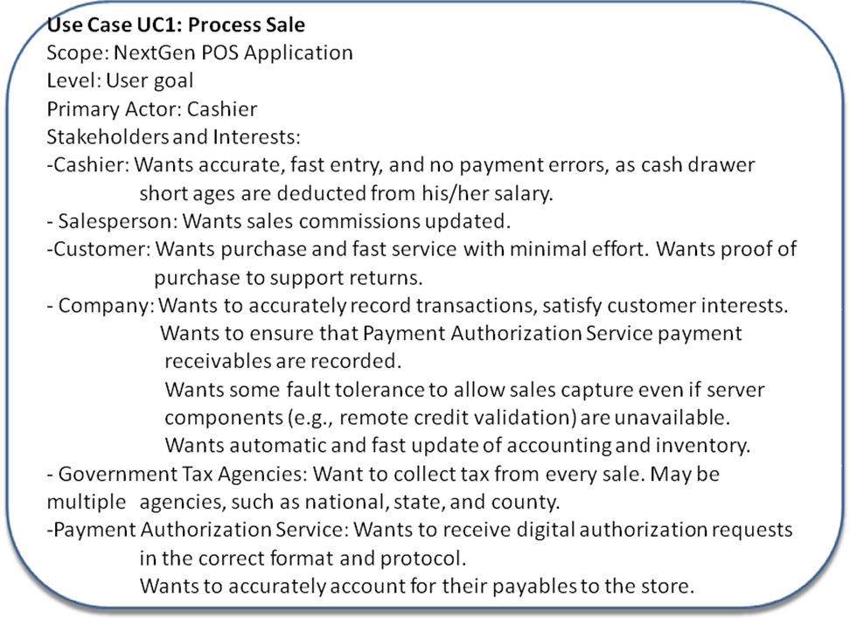
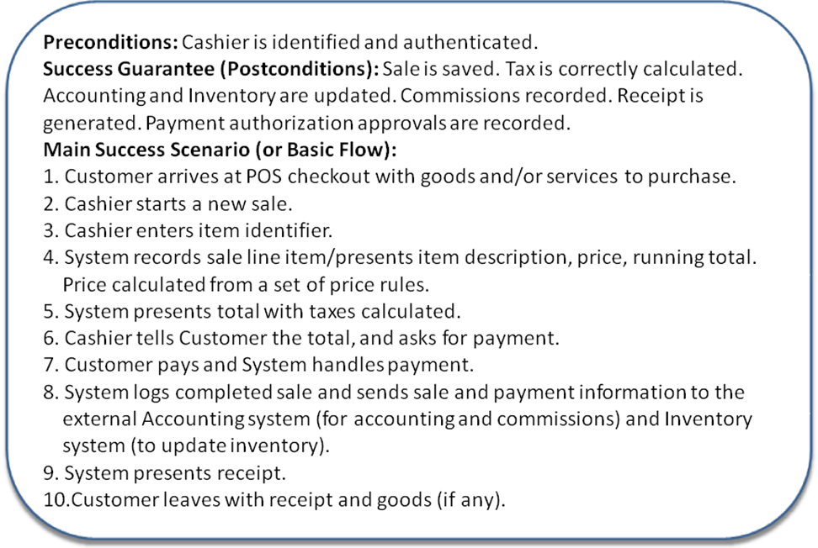
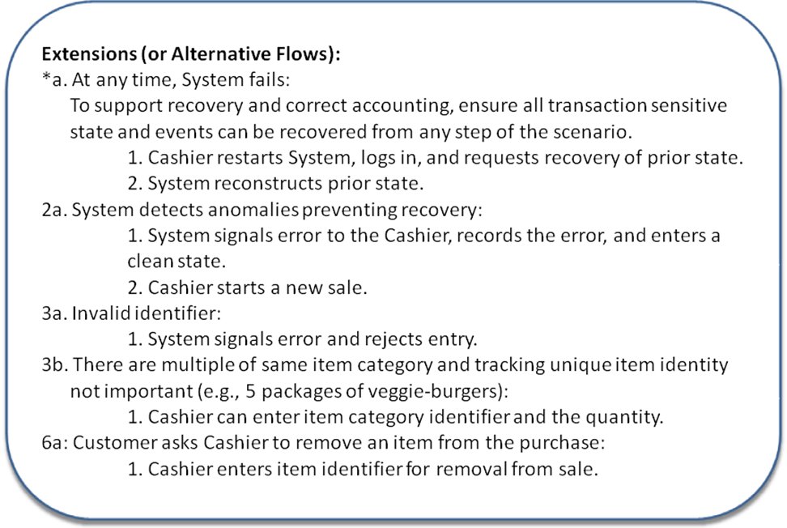
Frequency of Occurrence: Could be nearly continuous.
Open Issues:
- What are the tax law variations?
- Explore the remote service recovery issue.
- What customization is needed for different businesses?
- Must a cashier take their cash drawer when they log out?
- Can the customer directly use the card reader, or does the cashier have to do it?

Preconditions state what must always be true before beginning a scenario in the use case.
A precondition implies a scenario of another use case that has successfully completed, such as logging in, or "cashier is identified and authenticated”.

Success guarantees (or postconditions) state what must be true on successful completion of the use case. either the main success scenario or some alternate path.
The guarantee should meet the needs of all stakeholders.
Sale is saved. Tax is correctly calculated.
Accounting and Inventory are updated. Commissions recorded. Receipt is generated.
Extensions (or Alternate Flows) indicate all the other scenarios or branches, both success and failure. They are also known as "Alternative Flows."
Special Requirements
If a non-functional requirement, quality attribute, or constraint relates specifically to a use case, record it with the use case. These include qualities such as performance, reliability, and usability, and design constraints (often in I/O devices) that have been mandated or considered likely.
A Two Column Format : Typical Course of Events
Actor Action System Response
Numbered action of the actor Numbered description of system response
Alternative Course of events describes important alternatives or exceptions that may arise with respect to typical course.

Actor Action | System Response
1. The use case begins when a Customer arrives at a POST checkout with Items to purchase  2. The Cashier records the identifier from each item  If there are more than one of the same type of item, the cashier can enter the quantity as well.  4. On completion of item entry the Cashier indicates to the POST that item entry is complete. | 3. Determines the item price and adds the item information to the running sales transaction.  The description and price of the current item are presented.  5. Calculates and presents the sales total.
6. The Cashier tells the Customer the Total  7. The customer gives cash payment- the “cash tendered “- possibly greater than the sale total.  8. The Cashier records the cash received amount | 9. Shows the balance due back to the Customer.  Generates a receipt…
10. The Cashier deposits the cash received and extract the balance owing  12. The customer leaves with the items purchased | 11. Logs the completed sale.

Alternative Course
Line 2: Invalid identifier entered. Indicate error
Line 7: Customer didn’t have enough cash. Cancel sales transaction

Actor
It is an entity that is external to the system, who in some way participates in the story of Use Case.
An Actor typically stimulates the system with input events, or receives something form it. Actors are represented by the role they play in the Use Case.
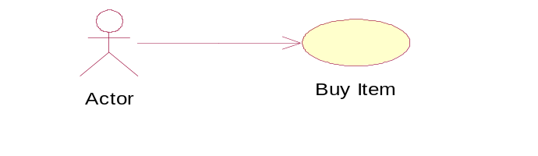
Actors can include

- Roles that people play
- Computer System
- Electrical or Mechanical Devices

Types of Actors
Primary actors have user goals fulfilled thru using services of system under discussion. e.g. cashier . These are identified to find user goals that drive use cases
Supporting actors provide service or information to the system. e.g. automated payment authorization. These are identified to clarify external interfaces and protocols
Offstage actor has interest in the behavior of the use case . e.g. government tax agency. These are identified to ensure all interests are identified and satisfied
Scenario
A scenario is a specific sequence of actions and interactions between actors and the system under discussion; it is also called a use case instance.
A use case is a collection of related success and failure scenarios that describes an actor using a system to support a goal
Use cases are functional or behavioral requirements that indicate what the system will do
Common Mistakes with the Use Cases
Remember: A use case is a relatively large end to end process description that typically includes many steps or transactions; it is not normally an individual step or activity in a process. e.g printing a receipt; is not a use case but a step in a use case called Buy_Item

Finding Primary Actors, Goals, and Use Cases
1. Choose the system boundary.
Is it just a software application, the hardware and application as a unit, that plus a person using it, or an entire organization?
2. Identify the primary actors.
Those that have user goals fulfilled through using services of the system.
3. For each, identify their user goals.
Raise them to the highest user goal level that satisfies the EBP guideline.
4. Define use cases that satisfy user goals; name them according to their goal.
Usually, user goal-level use cases will be one-to-one with user goals.
System and their boundaries:
A use case describes interaction with the system. Typical boundaries includes
- Hardware/software boundary of a device or computer system.
- Department of an organization.
- Entire organization.
The system boundary is important as it identifies:
- what is external versus internal.
- the responsibilities of the system
Scenario one:
If we choose the entire store or business as the system then the only customer is an actor not the cashier because the cashier acts as a resource within the business system.
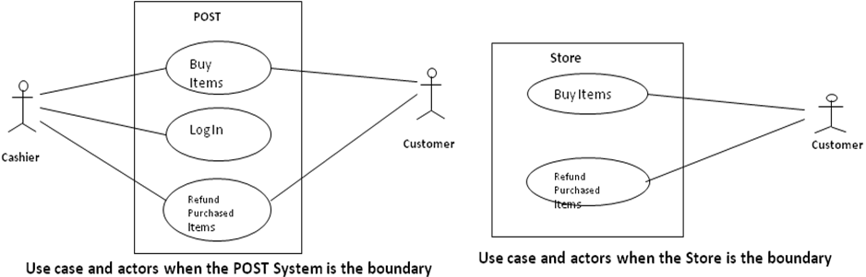
Scenario two:
If we choose the point of sale hardware and software as the system both cashier as well as customer may be treated as actors.
Identifying the Use Cases
Method 1 (Actor based)
Identifying the actor related to a system or organization and then for each actor, identifying the processes they initiate or participate in.
Using actor goal list
A recommended procedure:
1. Find the user goals.
2. Define a use case for each.
Actor Goal
Cashier process sales, process rentals, handle return, cash in , cash out
Manager start up , shut down
System Admin add users, modify users, delete users, manage security, manage system tables
Sales Activity Sys. analyze sales and performance data
Customer Buy Items, Refund Items
Method 2 (External events based)
Identifying the external events that a system must respond to and then relating the events to actor and use cases.
External Event Actor Goal/use case
Enter sale line item Cashier process a sale
Enter payment Cashier or customer process a sale

Naming Use Case and Domain Processes
A use case describes a process (Business process) , it is a complete run of a scenario e.g. all of the events that occur from the time a customer enters the ATM station till the time he comes out with cash with one goal achieved that includes inserting card, validation etc.
A process describes, from start to finish, a sequence of events, actions and transactions required to produce or complete something of value to an organization or actor
Process e.g. Withdraw Cash form ATM, Order a Product
A use case name starts with a verb. So naming a uses case based on goal:
Goal: Process a sale Use case: ProcessSale
Use Cases, System Functions and Traceability
Identified system functions in requirements specification should be allocated to Use Cases
Using Cross reference of the Use Cases, all functions that have been allocated should be verified, this helps in traceability between the artifacts
Essential versus Real use cases:
Essential use cases
- created during early stage of eliciting the requirements
- independent of the design decisions
- very abstract
High level use cases are always essential in nature due to their brevity (concise) and abstractions.
It is desirable to create essential use cases during only requirements, elicitations in order to more fully understand the scope of the problem and the functions required.
Essential use case
Actor action System response
1. customer identifies themselves 2. Provide Customer with options
3. ……
Real use cases
- Describe the functionality of the system in terms of its actual current design committed to specific input output technologies
- Developed only after the design decisions have been made
- Design artifacts
- very concrete
This concretely describes the process in terms in its rare current design committed to specific input and output technologies and so on.
Real use case
Actor action System response
1. customer inserts their cards 2. Prompts for PIN
3. enters PIN on key pad 4. Displays option menu
Use Case Degree of Design Commitment
Analysis Design
Essential very abstract
Real very concrete

Buy Items use case
Essential
Actor action System response
1. Cashier records identifier for each item 2. Determine the item price and add the item info
If there is more than one of the same to the running sales transaction description
The cashier enters quantity price of the current item in item presented
Real
Actor action System response
1. For each item cashier types UPC 2. Display item price and add the item information
in the UPC input field of window then to the running sales transactions the description
They press “enter item” button and price of current item are displayed
with the mouse or keyboard
Notational Points: Naming Use Cases
- Name a use case starting with a verb to emphasize that it is a verb
e.g. Buy_Items, Enter_Order
- Starting off an Expanded Use Case, use the Following Schema
This use case begins when an <Actor> <initiates an event>
This use case begins when a customer arrives at a POST with items to purchase
Notating Decision Points and Branching
A Use case may contain decision points. For e.g. A customer may choose to pay via cash, credit, or check.
If all alternatives are relatively equal, the notational structure is as follows
Section: Main
Typical course of Events
Actor Action
This use case begins when a Customer arrives at POST to check out with items to purchase
Intermediate steps
Customer chooses payment type
If cash payment, Pay by Cash
If credit payment, Pay by Credit
If check payment, Pay by Check

6. The cashier gives the receipt to the customer.
7. The customer leaves …
System Response

4. Logs the completes sales
5. Prints a receipt

Section: Pay by Cash
Typical Course of Events
Actor Action
1. The Customer gives cash payment possibly greater than the sale total to the cashier.
2. The Cashier records the cash amount
4. The Cashier deposits the cash received and extracts the balance owing.
The Cashier gives balance owing to the customer.

System Response

3. Shows the balance due back to the Customer

Alternative Courses:
Line 4: Insufficient balance in the drawer to pay balance, ask for cash from supervisor, or ask amount closer to sale total from the Customer
Use Cases within a Development Process
Plan and Elaborate Phase steps
After the System Functions have been listed, define the System boundary and then Identify Actors and the Use Cases
Write down all the Use Cases in High Level Format and categorize them as Primary and Secondary or optional
Draw a Use Case diagram
- Relate Use Cases
- Write the most critical, influential and risky use cases in the expanded format to better understand and estimate the size and nature of the problem.
- Real use case should be deferred (delayed) as they involve design decisions
- Rank Use cases
Process Steps for the Point of Sale System
Identifying Actors and Use Cases
The system boundary is defined as Software and Hardware system---the Usual Case
A list of relevant Actors include

Cashier | Log In/Cash Out
Customer | Buy Items/Refund Items
Manager | Start Up/Shut Down
System Administrator | Add New User

Draw a Use Case Diagram
Buy Items
Log In
Refund Purchased Items
Start Up
Manage Users
etc.
System Administrator

Cashier
Customer

Manager

Partial Use Case Diagram for the POST Application
Relate Use Case
Write Some Expanded Essential Use Cases
These Include Buy Items and Refund Purchased Items
Writing these in expanded form gives clear and better understanding
Use Case: Buy Items
Section Main
Use Case:
Actors:
Purpose
Overview

Type
Cross Reference
Buy Items
Customer (initiator), Cashier
Capture a sale and its payment
A Customer arrives at a check out with Items to purchase. The cashier records the purchased items and collects a payment. On completion the customer leaves with the items
primary
R1.1, R1.2, R1.3, R1.7, R1.9, R2.1, R2.2, R2.3, R2.4

Use Case Diagrams
The UML provides use case diagram notation to illustrate the names of use cases can actors, and the relationships between them
System Administrator
cashier
Process Sale
HandleReturnss
ProcessRentalsse
Cash In
Analyze Activity
Manage Security
Manage Users
…………..
<<actor>>
Tax Collector
<<actor>>
Accounting System
<<actor>>
HR System
<<actor>>
Sales Activity System
Payment Authorization Service
Usecase
Actor
System Boundary
Communication link

The UML
The Unified Modeling Language (UML) is a language for specifying, visualizing, constructing, and documenting the artifacts of software systems, as well as for business modeling and other non-software systems .
The UML has emerged as the de facto and de jure standard diagramming notation for object-oriented modeling.
It started as an effort by Grady Booch and Jim Rumbaugh in 1994 to combine the diagramming notations from their two popular methods—the Booch and OMT (Object Modeling Technique) methods.
They were later joined by Ivar Jacobson, the creator of the Objectory method, and as a group came to be known as the three amigos.
Many others contributed to the UML, perhaps most notably Cris Kobryn, a leader in its ongoing refinement.
The UML is a language for

-visualizing
-specifying
-constructing
-documenting

UML is a language which combines vocabulary and rules that tells us how to create and read well-framed models
1. UML is a language for visualizing
Modeling of any system requires certain degree of visualization of the system.
If the developer directly codes the requirement of a system, he can have the following problems.
Communicating these conceptual models to others. As all speak different language, there are chances of error and understanding the system.
Something in a software cannot be understood unless they build modules that transcend the textual programming language.
If a developer never wrote down the models, that are in his head such information is lost forever from the implementation once the developer moved on.
In a system development some things are best modeled textually, while some are best modeled graphically.
Thus UML is such a language that is more than just a bunch of graphical symbols. Each symbol in contrast has a well defined semantics which is best for visualization
2. It is a language for specifying.
Specifying means building models that are precise, unambiguous and complete.
In particular UML addresses the specification of all the important analysis, design and implementation decisions that must be:
-Scientific -Distributed web-based services.
3. UML is a language for constructing.
The models of UML can directly be connected to a variety of programming languages i.e . It is possible to map a UML model to a programming language such as Java, C++, etc.
4. UML is a language for documenting.
A healthy software organization produces all sorts of artifacts in addition to executable code.
Their artifacts include:

Requirements
Architecture
Design
Source code
Project plans
Tests
Prototypes
Release

The UML addresses the documentation of a system’s architecture and all of its details. The UML also provides the language for expressing requirements and for test. Finally, the UML provides a language for modeling the activities of a project planning and release management
The word UML stands for Unified Modeling Language
The UML was adopted in 1997 as a standard by the OMG (Object Management Group, an industry standards body), and has continued to be refined in new OMG UML versions.
Unified because it …– Combines main preceding OO methods (Booch by Grady Booch, OMT by Jim Rumbaugh and OOSE by Ivar Jacobson)
Modeling because it is …– Primarily used for visually modeling systems. Many system views are supported by appropriate models
Language because …– It offers a syntax through which to express modeled knowledge
UML is not: T

• A visual programming language or environment
• A database specification tool
• A development process (i.e. an SDLC)
• A panacea (The ultimate solution)
• A quality guarantee

UML
Helps to reduce cost and time-to-market.
Helps managing a complex project architecture.
Helps to convey ideas between developers\designers\etc.
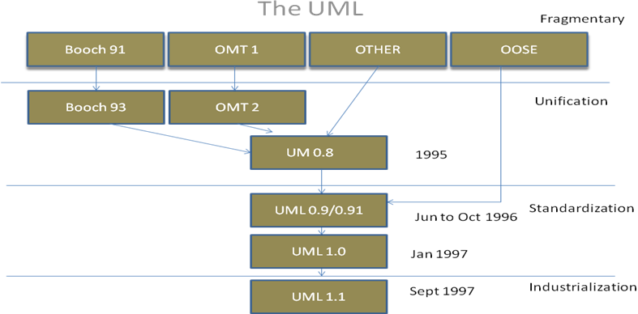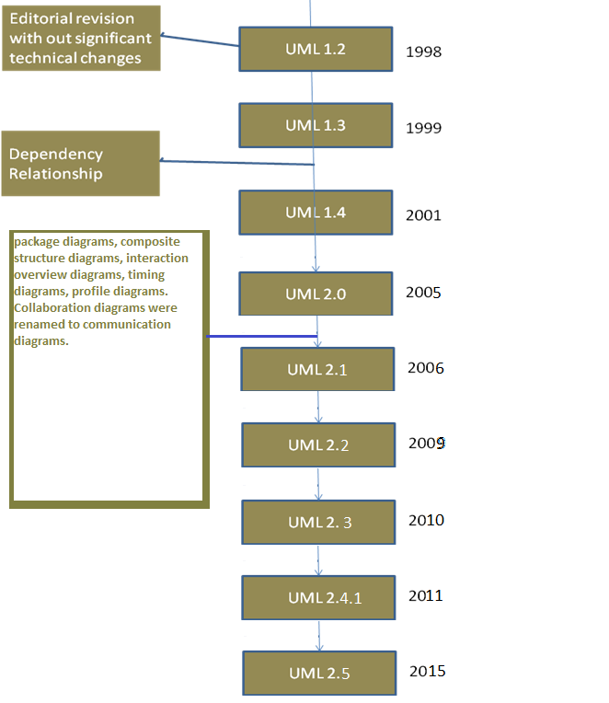
The UML: Terms and Concepts
A system is a collection of subsystems organized to accomplish a purpose and described by a set of models, possibly from different viewpoints.
A subsystem is a grouping of elements, of which some constitute a specification of the behavior offered by the other contained elements.
A model is a semantically closed abstraction of a system, meaning that it represents a complete and self-consistent simplification of reality, created in order to better understand the system.
A view is a projection into the organization and structure of a system's model, focused on one aspect of that system.
A diagram is the graphical presentation of a set of elements, most often rendered as a connected graph of vertices (things) and arcs (relationships).
To understand UML we require three major elements learning; the UML’s building blocks, the rules that dictate how those building blocks may be put together and some common mechanism that apply throughout the UML.
The vocabulary of UML encompasses three kinds of building blocks:

- Things.
- Relationship.
- Diagrams

Things: Those are abstractions that are first class citizens in UML modeling.
There are four kinds of things in UML.

- Structural things.
- Behavioral things.
- Grouping things
- Annotational things.

Structural things:-
These are the nouns of the UML models. They are the static part of the model representing elements that are either conceptual or physical.

- Active Class - Component
- Node etc.

Behavioral things
- Interaction - State machine etc.
Grouping things
- Package
Annotational things
- Note
Relationships in UML

- Dependency
- Association
- Generalization
- Realization

Classification of UML Diagrams
UML specification defines two major kinds of UML diagram: structure diagrams and behavior diagrams
UML diagrams could be categorized hierarchically as shown below:
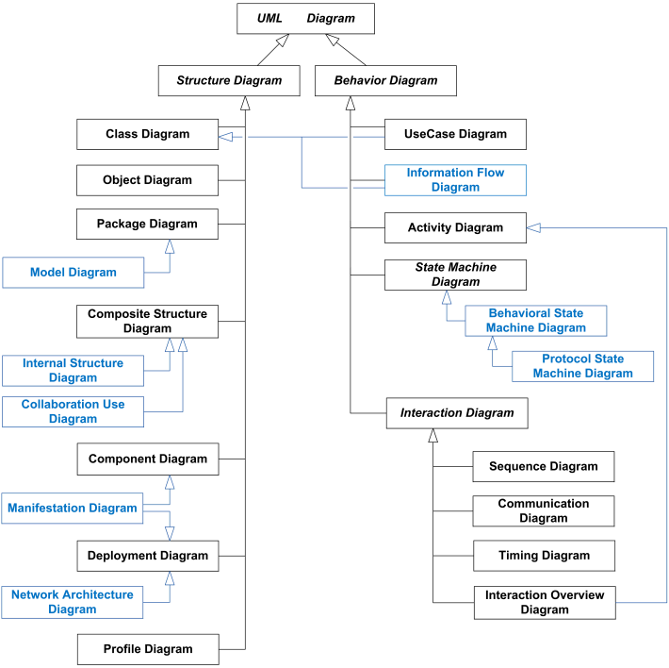
A. Structural Diagrams
Static aspects of a house: walls, doors, windows, pipes, wires, and vents,
Static aspects of a software system : classes, interfaces, components, and nodes.
Used to describe the building blocks of the system
– features that do not change with time.
These diagrams answer the question – What’s there?
Structure diagram shows static structure of the system and its parts on different abstraction and implementation levels and how those parts are related to each other.
The elements in a structure diagram represent the meaningful concepts of a system, and may include abstract, real world and implementation concepts.
Structure diagrams are not utilizing time related concepts, do not show the details of dynamic behavior. However, they may show relationships to the behaviors of the classifiers exhibited in the structure diagrams.
1. Class diagram
It is a static structure diagram which describes structure of a system at the level of classifiers (classes, interfaces, etc.).
It shows some classifiers of the system, subsystem or component, different relationships between classifiers, their attributes and operations, constraints
Class diagrams commonly contain the following things:

· Classes
· Interfaces
· Collaborations
· Dependency, generalization, and association relationships

Class diagrams are static – display what interacts but not what happens when interaction occurs.
May contain notes and constraints.
They are used :
1. To model the vocabulary of a system
Making a decision about which abstractions are apart of the system under consideration and which fall outside its boundaries. Used to specify these abstractions and their responsibilities.
2. To model simple collaborations

A collaboration is a society of classes, interfaces, and other elements that work together to provide some cooperative behavior
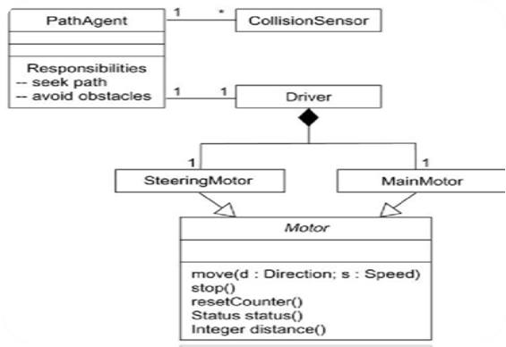

3. To model a logical database schema
The blueprint for the conceptual design of a database.
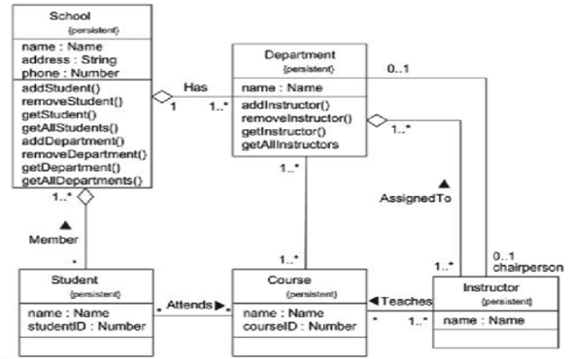
Classes are represented by a rectangle divided to three parts: class name, attributes and operations.
Attributes are written as:
visibility name [multiplicity] :type-expression =initial-value
Operations are written as:
visibility name (parameter-list) :return type-expression
Visibility is written as:

+public
#protected
-private

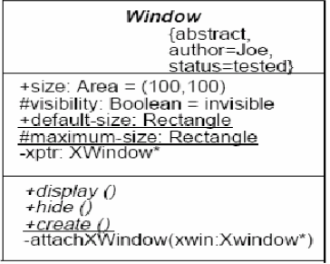
Class Diagram Relationships
Association –
Two classes are associated if one class has to know about the other. (uses)
Aggregation –
An association in which one class belongs to a collection in the other.(whole part)
Generalization –
An inheritance link indicating one class is a base class of the other.
Dependency –
A labeled dependency between classes ( such as friend, classes)
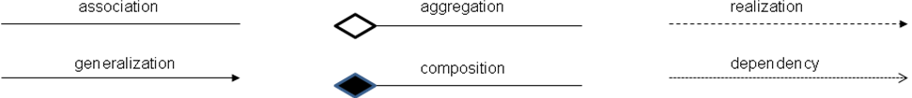
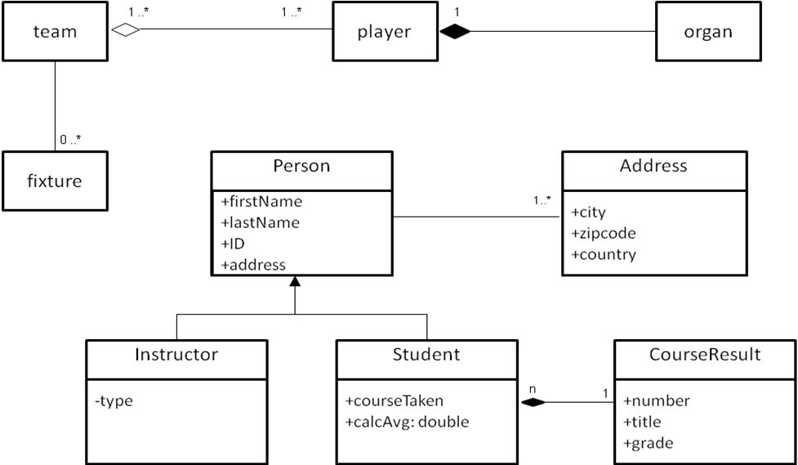

2. Object Diagram
Now obsolete, is defined as "a graph of instances, including objects and data values. A static object diagram is an instance of a class diagram; it shows a snapshot of the detailed state of a system at a point in time."
An object diagram shows a set of objects and their relationships.
Used to illustrate data structures, the static snapshots of instances of the things found in class diagrams.
Object diagrams address the static design view or static process view of a system just as do class diagrams, but from the perspective of real or prototypical cases.
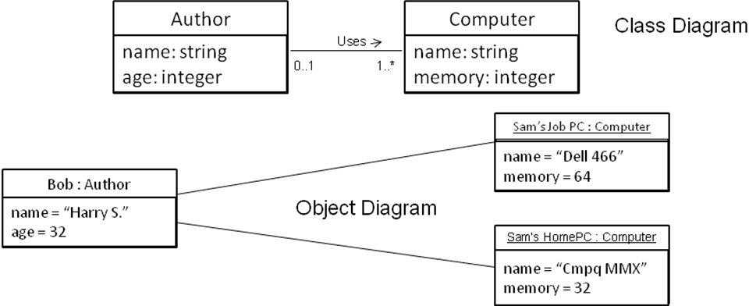
3. Package diagram
Shows packages and relationships between the packages.
Package diagram includes the following elements: package, packageable element, dependency, element import, package import, package merge.
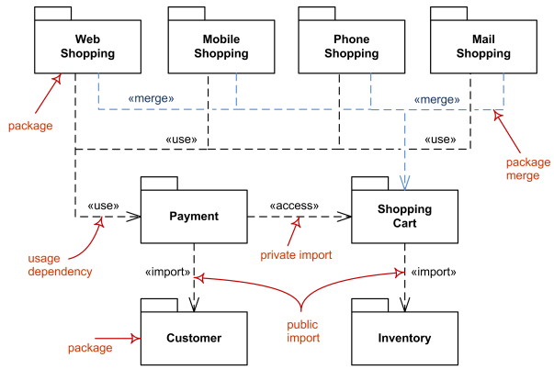

Model diagram
It is UML auxiliary structure diagram which shows some abstraction or specific view of a system, to describe architectural, logical or behavioral aspects of the system. It could show, for example, architecture of a multi-layered (aka multi-tiered) application - multi-layered application model.
In the diagram below, Layered Application is a "container" model which contains three other models - Presentation Layer, Business Layer, and Data Layer. There are dependencies defined between these contained models.
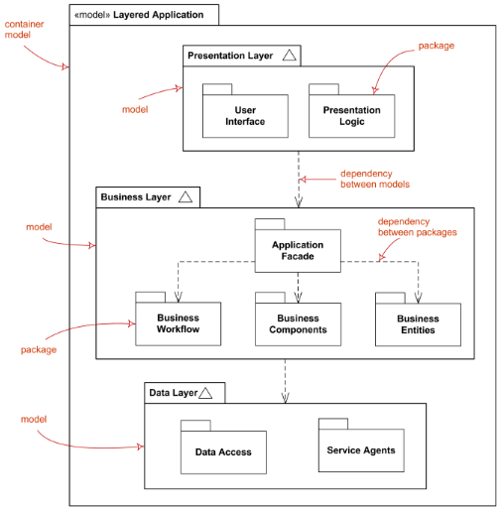
4. Composite structure diagram
It could be used to show:
- Internal structure of a classifier
- A behavior of a collaboration
a. Internal Structure diagrams show internal structure of a classifier - a decomposition of the classifier into its properties, parts and relationships.
A composite structure diagram that shows internal structure of a classifier includes the following elements: class, part, port,connector, usage.
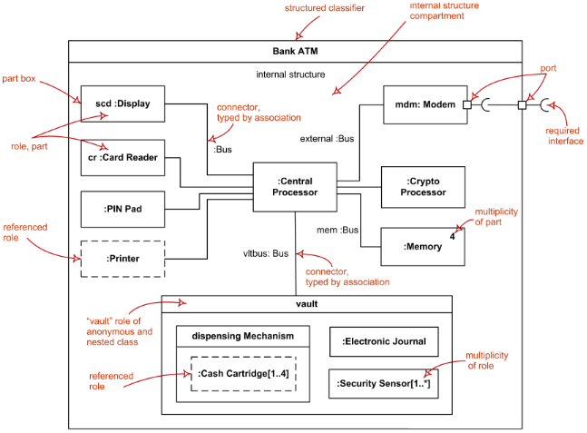
b. Collaboration use diagram shows objects in a system cooperating with each other to produce some behavior of the system.
A behavior of a collaboration will eventually be exhibited by a set of cooperating instances (specified by classifiers) that communicate with each other by sending signals or invoking operations. However, to understand the mechanisms used in a design, it may be important to describe only those aspects of these classifiers and their interactions that are involved in accomplishing a task or a related set of tasks, projected from these classifiers.
Collaborations allow us to describe only the relevant aspects of the cooperation of a set of instances by identifying the specific roles that the instances will play.
Interfaces allow the externally observable properties of an instance to be specified without determining the classifier that will eventually be used to specify this instance. Consequentially, the roles in a collaboration will often be typed by interfaces and will then prescribe properties that the participating instances must exhibit, but will not determine what class will specify the participating instances.
A composite structure diagram that shows behavior of a collaboration includes the following elements: collaboration,connector, part, collaboration specialization, dependency.
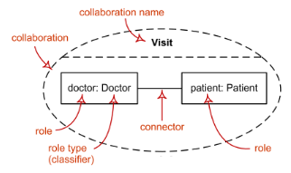
Collaboration use represents one particular use (occurrence) or application of the pattern described by a collaboration to a specific situation involving specific classes or instances playing the roles of the collaboration. A collaboration use shows how the pattern described by a collaboration is applied in a given context, by binding specific entities from that context to the roles of the collaboration.
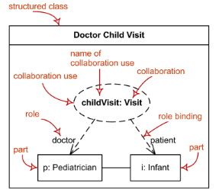
Classifier (in internal structures and collaborations) is extended with the capability to own collaboration uses. These collaboration uses link acollaboration with the classifier to give a description of the behavior of the classifier.
5. Component Diagram
Shows a set of components and their relationships.
Used to illustrate the static implementation view of a system.
Component diagrams are related to class diagrams in that a component typically maps to one or more classes, interfaces, or collaborations.
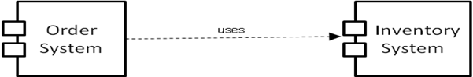
6. Deployment Diagram
A deployment diagram shows a set of nodes and their relationships.
Used to illustrate the static deployment view of an architecture.
Deployment diagram shows architecture of the system as deployment (distribution) of software artifacts to deployment targets.
Components were directly deployed to nodes in UML 1.x deployment diagrams. In UML 2.x artifacts are deployed to nodes, and artifacts could manifest (implement) components. Components are deployed to nodes indirectly through artifacts.
Specification level deployment diagram (also called type level) shows some overview of deployment of artifacts to deployment targets, without referencing specific instances of artifacts or nodes.

Instance level deployment diagram shows deployment of instances of artifacts to specific instances of deployment targets. It could be used for example to show differences in deployments to development, staging or production environments with the names/ids of specific build or deployment servers or devices.
While component diagrams show components and relationships between components and classifiers, and deployment diagrams - deployments of artifacts to deployment targets

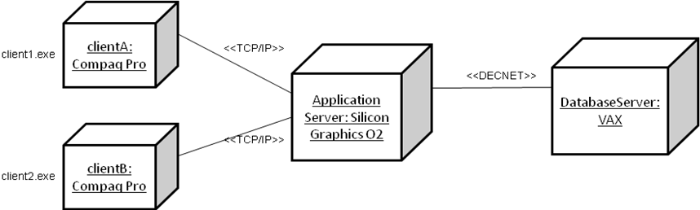
Manifestation diagram
It is the missing intermediate diagram used to show manifestation (implementation) of components by artifacts and internal structure of artifacts.
Manifestation of components by artifacts could be shown using either component diagrams or deployment diagrams.
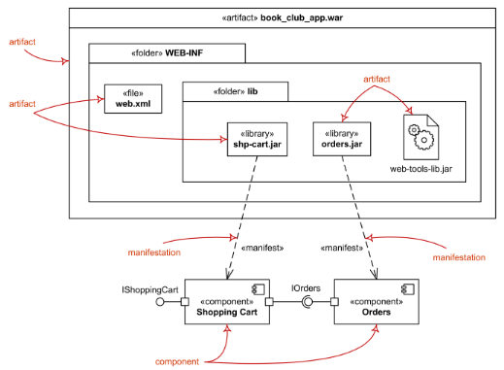
Network architecture diagram is a kind of deployment diagram that is used to show logical or physical network architecture of the system.
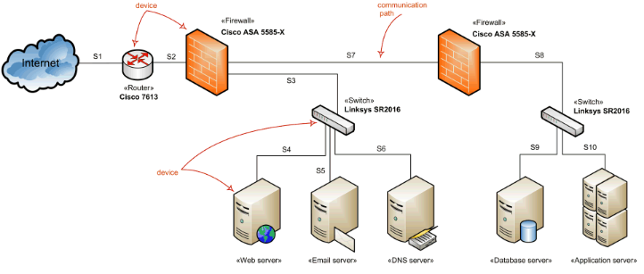

7. Profile diagram
It is auxiliary UML diagram which allows defining custom stereotypes, tagged values, and constraints. The Profile mechanism has been defined in UML for providing a lightweight extension mechanism to the UML standard. Profiles allow to adapt the UML metamodel for different
- platforms (such as J2EE or .NET), or
- domains (such as real-time or business process modeling).
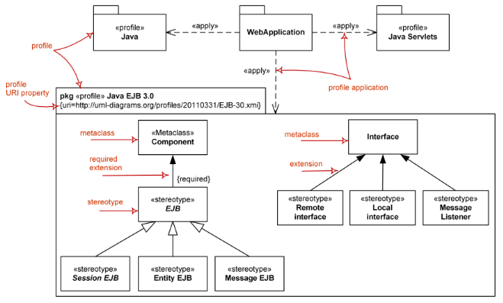
B. Behavioral Diagrams
The UML's behavioral diagrams are used to visualize, specify, construct, and document the dynamic aspects of a system.
Dynamic aspects of a system represent its changing parts.
They show the dynamic behavior of the objects in a system, which can be described as a series of changes to the system over time.

Used to show how the system evolves over time (responds to requests , events etc)
The UML's behavioral diagrams are roughly organized around the major ways you can model the dynamics of a system.
1. Use Case Diagram
A use case diagram shows a set of use cases and actors (a special kind of class) and their relationships.
Use case diagrams are especially important in organizing and modeling the behaviors of a system.
Describes what a system does from the standpoint of an external observer.
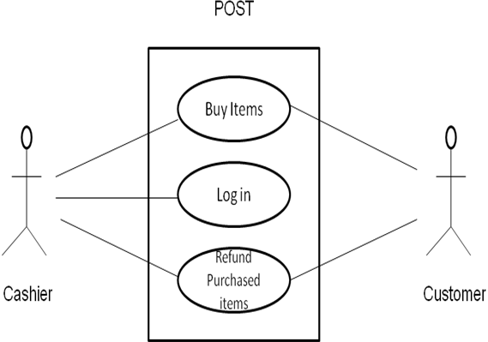
Emphasis on what a system does rather than how.
Scenario – Shows what happens when someone interacts with system.
Actor – A user or another system that interacts with the modeled system.
A use case diagram describes relationships between actors and scenarios.
Provides system requirements from the user’s point of View.
Use case Relationships:
Association – defines a relationship between an actor and a use case.
Extend - defines that instances of a use case may be augmented with some additional behavior defined in an extending use case.
Use/Include - drawn as a dependency relationship that points from the base use case to the used use case.
- defines that a use case uses a behavior defined in another use case.
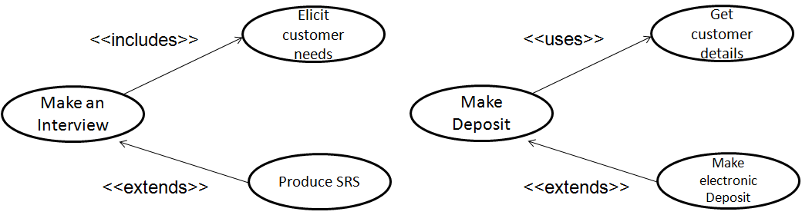
Use Case Diagram
- Attention focused on the part of the business process that is going to be supported by the IS.
- It is the end-user perspective model.
- It is goal driven
- It helps to identify system services.
- It is not used as DFDs.
- Sequences, branching, loops, rules, etc. cannot (and should not) be directly expressed.
They are used to describe a set of actions (use cases) that some system or systems (subject) should or can perform in collaboration with one or more external users of the system (actors) to provide some observable and valuable results to actors or other stakeholders of the system(s).
UML specification also defines use case diagrams as specialization of class diagrams (which are structure diagrams). Use case diagrams could be considered as a special case of class diagrams where classifiers are restricted to be either actors or use cases and the most used relationship is association.
Information flow diagram is UML behavior diagram which shows exchange of information between system entities at some high levels of abstraction. Information flows may be useful to describe circulation of information through a system by representing aspects of models not yet fully specified or with less details.
Information flows do not specify the nature of the information, mechanisms by which it is conveyed, sequences of exchange, or any control conditions. Information items can be used to represent the information that flows through a system along the information flows before details of their realization have been designed.
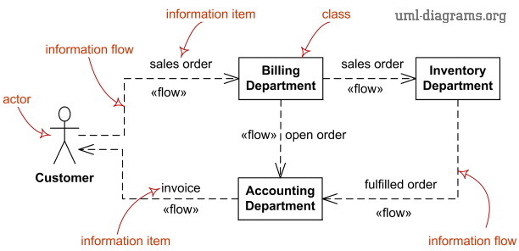
Limitations of Information Flow Diagrams
Information flow diagrams in UML provide fairly meager expressive capabilities.
Information items provide no details about the information they transfer. They do not have features, generalizations, or associations.
2. Activity Diagram
An activity diagram shows the flow from activity to activity within a system.
An activity shows a set of activities, the sequential or branching flow from activity to activity, and objects that act and are acted upon.
Shows what activities can be done in parallel, and any alternate paths through the flow
Activity diagrams contain activities, transitions between the activities, decision points, and synchronization bars
Activity diagrams emphasize the flow of control among objects.
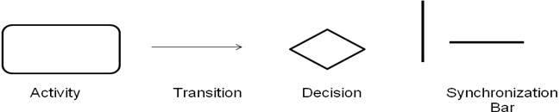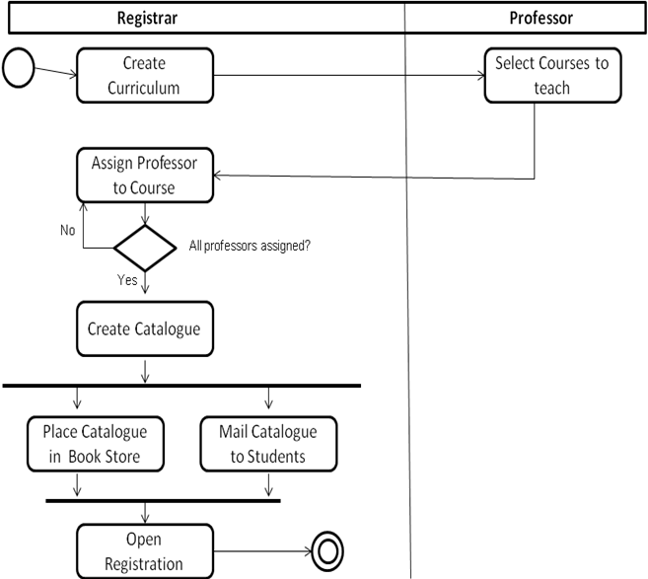
3. State machine diagram
It is used for modeling discrete behavior through finite state transitions.
In addition to expressing the behavior of a part of the system, state machines can also be used to express the usage protocol of part of a system. These two kinds of state machines are referred to as behavioral state machines and protocol state machines.
A statechart diagram shows a state machine, consisting of states, transitions, events, and activities.
They are especially important in modeling the behavior of an interface, class, or collaboration.
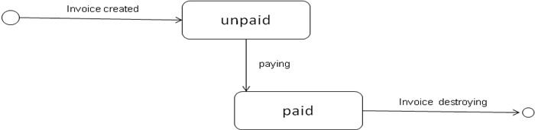
Statechart diagrams emphasize the event-ordered behavior of an object, which is especially useful in modeling reactive systems.
Interaction diagrams include several different types of diagrams:
- sequence diagrams,
- interaction overview diagrams,
- communication diagrams, (known as collaboration diagrams in UML 1.x)
- timing diagrams.

4. Sequence Diagram
A sequence diagram is an interaction diagram that emphasizes the time ordering of messages and shows a set of objects and the messages sent and received by those objects.
The objects are typically named or anonymous instances of classes, but may also represent instances of other things, such as collaborations, components, and nodes.
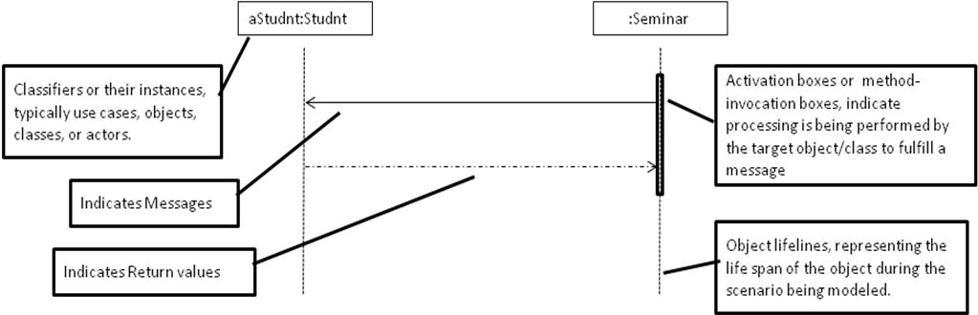
A sequence diagram is an interaction diagram that emphasizes the time ordering of messages.
A sequence diagram shows a set of objects and the messages sent and received by those objects.
The objects are typically named or anonymous instances of classes, but may also represent instances of other things, such as collaborations, components, and nodes.
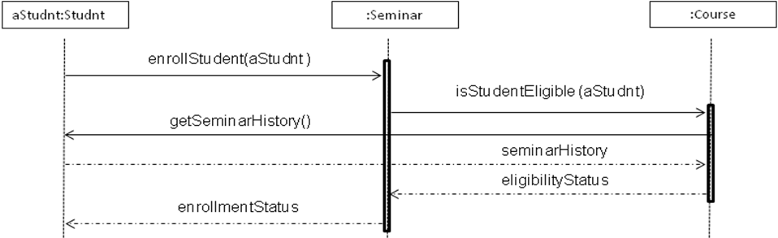
5. Communication diagram (previously known as Collaboration Diagram)
It is a kind of interaction diagram, which focuses on the interaction between lifelines where the architecture of the internal structure and how this corresponds with the message passing is central.
The sequencing of messages is given through a sequence numbering scheme.
It is an interaction diagram that emphasizes the structural organization of the objects that send and receive messages.
A collaboration diagram shows a set of objects, links among those objects, and messages sent and received by those objects.
The objects are typically named or anonymous instances of classes, but may also represent instances of other things, such as collaborations, components, and nodes.
Lifeline is a specialization of named element which represents an individual participant in the interaction. While parts and structural features may have multiplicity greater than 1, lifelines represent only one interacting entity.
If the referenced connectable element is multivalued (i.e, has a multiplicity > 1), then the lifeline may have an expression (selector) that specifies which particular part is represented by this lifeline. If the selector is omitted, this means that an arbitrary representative of the multivalued connectable element is chosen.
A Lifeline is shown as a rectangle (corresponding to the "head" in sequence diagrams). Lifeline in sequence diagrams does have "tail" representing the line of life whereas "lifeline" in communication diagram has no line, just "head".
The lifeline head has a shape that is based on the classifier for the part that this lifeline represents. Usually the head is a white rectangle containing name of the class after colon.
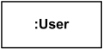
Anonymous lifeline of class User.
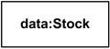
Lifeline "data" of class Stock
Message in communication diagram is shown as a line with sequence expression and arrow above the line. The arrow indicates direction of the communication.
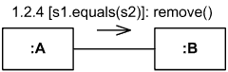
Sequence and collaboration diagrams are isomorphic, meaning that you can convert from one to the other without loss of information.
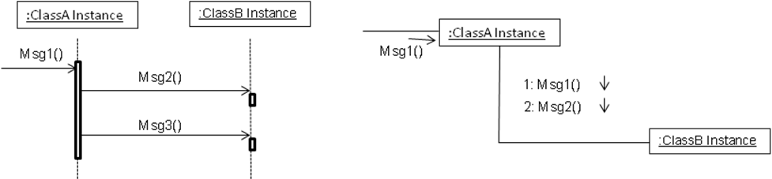
Difference between Communication Diagram and Sequence Diagram
A sequence diagram includes chronological sequence of messages
A sequence diagram does not include object relationships
Important to visualize timing order of messages
Communication diagram is used when you are interested in the structural relationships among the instances in an interaction
Communication diagram emphasizes on the organization structure
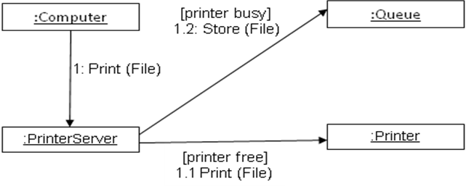
6. Timing diagrams
They are used to show interactions when a primary purpose of the diagram is to reason about time and focus on conditions changing within and among Lifelines along a linear time axis.
Elements used are lifeline, state or condition timeline, destruction event,duration constraint, time constraint.
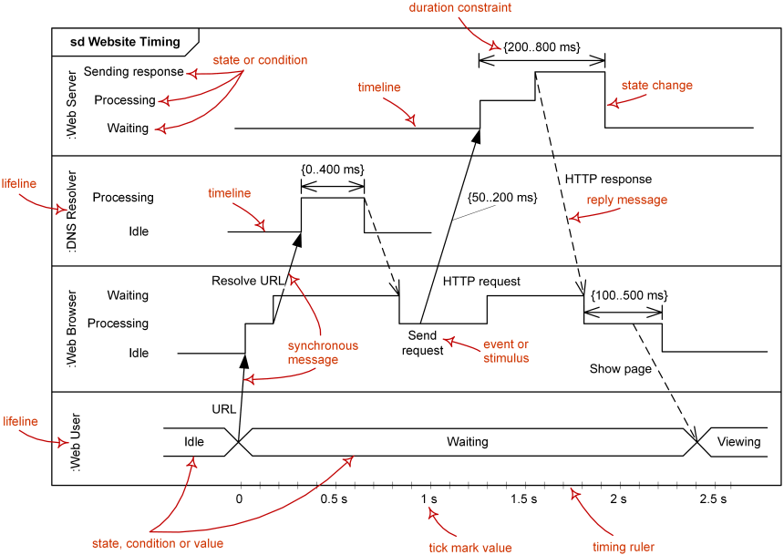

Lifeline
Lifeline is a named element which represents an individual participant in the interaction. While parts and structural features may have multiplicity greater than 1, lifelines represent only one interacting entity. See lifeline from sequence diagrams for details.
Lifeline on the timing diagrams is represented by the name of classifier or the instance it represents. It could be placed inside diagram frame or a "swimlane".
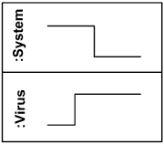
Lifelines representing instances of System and Virus

State or Condition Timeline
Timing diagram could show states of the participating classifier or attribute, or some testable conditions, such as a discrete or enumerable value of an attribute.
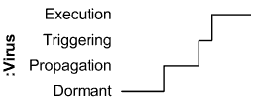
Timeline shows Virus changing its state between Dormant, Propagation, Triggering and Execution state
UML also allows the state/condition dimension be continuous. It could be used in scenarios where entities undergo continuous state changes, such as temperature or density.

Duration Constraint
Duration constraint is an interval constraint that refers to a duration interval. The duration interval is duration used to determine whether the constraint is satisfied.
The semantics of a duration constraint is inherited from constraints. If constraints are violated, traces become negative which means that system is considered as failed.
Duration constraint is shown as some graphical association between a duration interval and the constructs that it constrains.
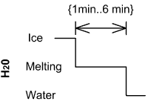
Ice should melt into water in 1 to 6 minutes

Time Constraint
Time constraint is an interval constraint that refers to a time interval. The time interval is time expression used to determine whether the constraint is satisfied.
The semantics of a time constraint is inherited from constraints. All traces where the constraints are violated are negative traces, i.e., if they occur, the system is considered as failed.
Time constraint is shown as graphical association between a time interval and the construct that it constrains. Typically this graphical association is a small line, e.g., between an occurrence specification and a time interval.
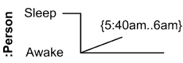
Person should wake up between 5:40 am and 6 am

Destruction Occurrence
Destruction occurrence is a message occurrence which represents the destruction of the instance described by the lifeline. It may result in the subsequent destruction of other objects that this object owns by composition. No other occurrence may appear after the destruction event on a given lifeline.

Notation
The destruction event is depicted by a cross in the form of an X at the end of a timeline.
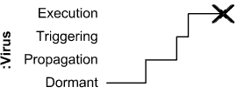
Virus lifeline is terminated
7. Interaction overview diagram
It defines interactions through a variant of activity diagrams in a way that promotes overview of the control flow.
Interaction overview diagrams focus on the overview of the flow of control where the nodes are interactions or interaction uses.
The lifelines and the messages do not appear at this overview level.
UML interaction overview diagram combines elements from activity and interaction diagrams.
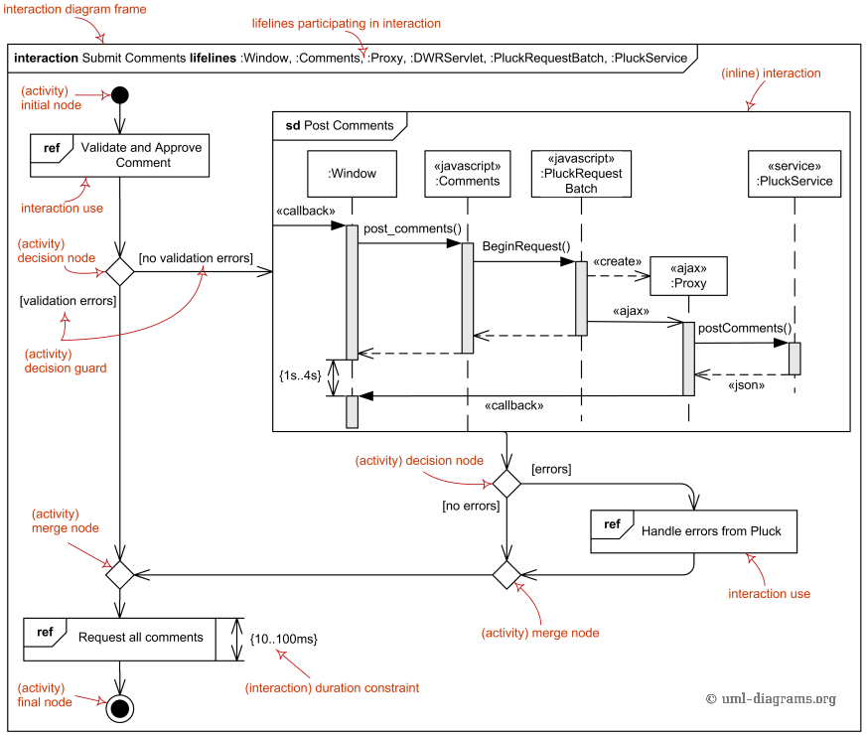
Frame
Interaction overview diagrams are framed by the same kind of frame that encloses other forms of interaction diagrams - a rectangular frame around the diagram with a name in a compartment in the upper left corner. Interaction kind is interaction or sd (abbreviated form). Note, that UML has no io or iod abbreviation as some would expect.
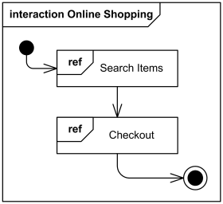
Interaction overview diagram Online Shopping
The heading text may also include a list of the contained lifelines (that do not appear graphically).
Elements of Activity Diagram
Interaction overview diagrams are defined as specialization of activity diagrams and as such they inherit number of graphical elements.
Interaction overview diagrams can only have inline interactions or interaction uses instead of actions, and activity diagram actions could not be used.
The elements of the activity diagrams used on interaction overview diagrams are initial node, flow final node, activity final node, decision node, merge node, fork node, join node
Elements of Interaction Diagram
The elements of the interaction diagrams used on interaction overview diagrams are interaction, interaction use, duration constraint, time constraint
Interaction
An interaction diagram of any kind may appear inline as an invocation action. The inline interaction diagrams may be either anonymous or named.
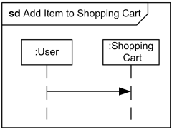
Interaction Add Item to Shopping Cart may appear inline on some interaction overview diagram
Interaction Use
An interaction use may appear as an invocation action.
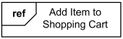
Interaction use Add Item to Shopping Cart may appear on some interaction overview diagram

